hi

Mid-Term Examination:SOLUTION
(Fall, 1999-2000)
ENGG 201 - Behaviour of Liquids, Gases and Solids

October 28, 1999 Time Allowed: 90 minutes

PROBLEM I (15 points)
The flow of a fluid in a circular tube is described by the following equation:
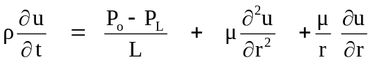
where: ρ: the fluid density,
μ: the fluid viscosity (S.I. units: kg.m⁻¹.s⁻¹),
L: length of the tube,
u: velocity of the fluid,
t: time,
r: radial position in the tube (length),
P_{o}, P_{L}: the pressures at the entrance and exit of the tube.
Show that the above equation is dimensionally homogeneous (use dimensions and not units).
Solution:
[P_{o}]=[P_{L}] = [Force/Area]== [M L t⁻²]/[L²]== [M] [L]⁻¹ [t]⁻²
[μ] = [ M] [L]⁻¹[ t]⁻¹
[ρ] = [mass/volume] ==[M][ L]⁻³
[u] = [L][t]⁻¹

[(P_{o}-P_{L})/L] ==[ P_{o}-P_{L}][L]⁻¹ ==[M] [L]⁻¹ [t]⁻² *[L]⁻¹ ==[M] [L ]⁻²[t]⁻²

[μ (δ²u/δr² ) ] ==[μ][(u/L²)] ==[M][L]⁻¹ [t]⁻¹* [L][t]⁻¹ [L]⁻² ==[M] [L ]⁻²[t]⁻²

[μ /r( δu/δr) ] ==[μ][L]⁻¹ [(u /L) ] ==[M][L]⁻¹[t]⁻¹* [L]⁻¹ *[L][t]⁻¹ *[L]⁻¹ ==[M] [L ]⁻²[t]⁻²

All terms appearing on the right hand side (RHS) have a dimension of [M][L]⁻²[t]⁻², therefore it is possible to add them and the dimension of the right hand side term is:
[RHS] ==[M] [L]⁻²[t]⁻²

The left hand side term (LHS) has dimension:
[L.H.S] ==[ρ][u][t]⁻¹ ==[M][L]⁻³*[L][ t]⁻¹*[t]⁻¹ ==[M] [L ]⁻²[t]⁻²

As a conclusion, the LHS and RHS terms have the same dimension. Therefore the equation is dimensionally homogeneous.

PROBLEM II (20 points)
The Lennard-Jones parameters for a non-polar substance are given as:
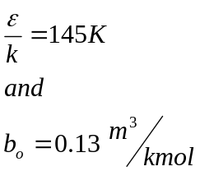
- Calculate the potential energy between two molecules of this substance when they are separated by a centre-to-centre distance of 4.5 x10⁻¹⁰ m.

- This pure substance has a molar mass of 96 kg/kmol and it crystallises in a simple cubic lattice.
Assuming that the intermolecular distance in the solid state corresponds to the minimum value of Lennard-Jones potential, estimate the density of this substance in the solid state.

Solution

- ε/k = 145 K; ε = 145 x 1.3805 x 10⁻²³ = 2.00 x 10⁻²¹ J
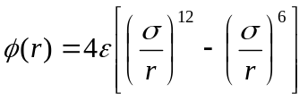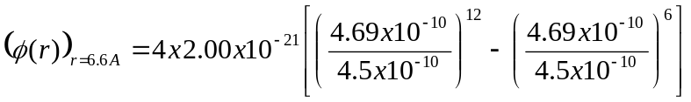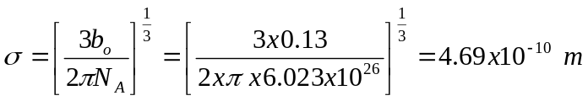

= 2.89 x10⁻²¹ J

(b) The minimum potential energy occurs at intermolecular distance of 1.122σ

d = 1.122σ = 1.122 x 4.69 x 10⁻¹⁰ m = 5.26 x 10⁻¹⁰ m

Mass of one molecule =(96 kg/kmol)/(6.023 x 10²⁶ molecules/kmol) = 1.593 x 10⁻²⁵ kg/molecule. Density for simple cubic lattice is given by m/d³

Therefore,

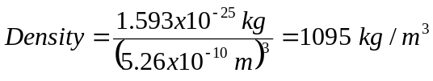
PROBLEM III (40 points)
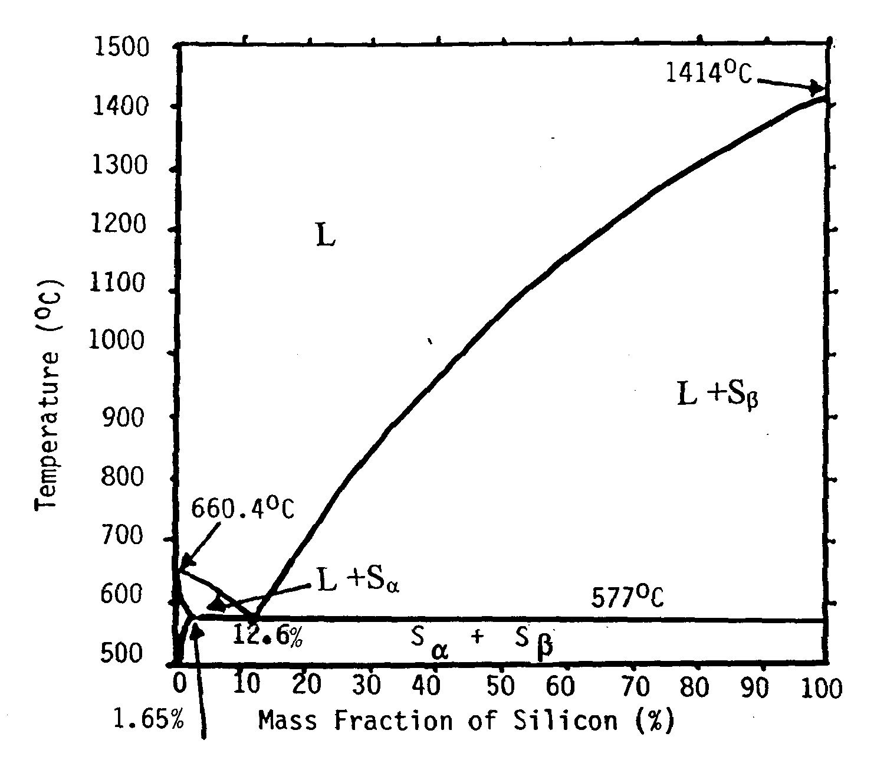
An important commercial alloy used in industry is the Aluminum-Silicon system (Al-Si). The figure below shows the phase diagram for this system.

- Use the diagram to determine the melting temperatures of pure Aluminum and Silicon.
- Use the diagram to determine the solubility of Aluminum in Silicon.
- Aluminum-Silicon alloys of approximately the eutectic composition are widely used as piston materials in the automotive industry. What is the eutectic composition for this system?
- A 100kg (Si-Al) mixture containing 40 mass percent of Aluminum is maintained at a temperature
of 1100 ºC. Answer the following questions:
- What are the phases present?
- What are the mass and molar compositions of each phase.
- The mixture in question 4 is brought to a temperature T=576ºC.
- What are the phases present?
- What is the composition and mass of solid S_{β} ?

Solution
1. Melting temperature of pure Aluminum is 660.4 ºC
Melting temperature of pure Silicon is 1414 ºC

2. The solubility of Aluminum in Silicon is zero.

3. The eutectic composition is 12.6% Silicon.

- 4. a- 40wt% Aluminum ➔ 60 wt% Silicon.
- There are two phases: Liquid and solid S_{β}.
b- The mass composition is: 100 wt% Silicon in solid phase (pure Silicon)
54 wt% Silicon in liquid phase.

The molar composition of solid is: 100 mol % Silicon. (pure Silicon)
To determine the molar composition of the liquid phase:
Consider 1kg of liquid mixture ➔ 0.54kg Silicon + 0.46kg Aluminum. = m₁ +m₂

The molar mass of Silicon is M₁ = 28kg/kmol
The molar mass of Aluminum is M₂ = 27kg/kmol
The number of moles of Silicon in the liquid: n₁ = (m₁/ M₁)=0.54/28 =0.019 kmol
The number of moles of Aluminum in the liquid: n₂ = (m₂ /M₂)=0.46/27 =0.017 kmol

➔ The mole fraction of Silicon in the liquid phase is : n₁/ (n₁+n₂)
= 0.019/0.036= 0.53 or 53 mol%.

5. a-There are two phases solid S_{α} and solid S_{β}.

- b-The solid phase is pure Silicon (100 wt%).
Using the lever rule, we can determine the mass of S_{β}:

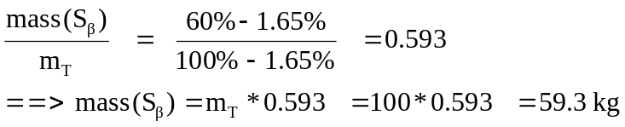

PROBLEM IV (25 points)
A laboratory technician was preparing a gas mixture for testing. He started by evacuating a 0.01m³ pressure vessel (internal volume) to a very high vacuum so that the vessel was totally empty. Then he injected methane gas (CH₄) into the vessel and allowed it to reach a stable temperature of 20 ºC. The gas pressure in the vessel at this point was 1500 kPa.
N.B. Molar mass of methane 16.043 kg/kmol
Molar mass of ethane 30.070 kg/kmol
Molar mass of propane 44.097 kg/kmol
Universal gas constant 8314 J/(kmol.K)
1. Assuming ideal gas behaviour, determine the number of kmole of methane added to the vessel.

2.The technician then connected the vessel already containing methane, to a source of high pressure ethane (C₂H₆) and very slowly injected enough ethane into the vessel to increase the total pressure to 2500 kPa. The vessel temperature remained at 20 ºC. Assuming ideal gas behaviour, determinee the number of kmole of ethane added to the vessel.
3.Finally the technician added 0.010 kg of propane (C₃H₈) into the vessel containing ethane and methane, and waited for the system to reach equilibrium at 20 ºC.Calculate the final pressure in the vessel, again assuming ideal gas behaviour.
Solution:
1. Number of kmol of methane = n₁ = (PV)/RT
with P = 1500 kPa, V = 0.01 m³, T = 293.15 K, R = 8314 J/kmol K.
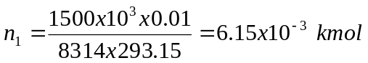

2. Let n₁ + n₂ = kmol of methane and ethane

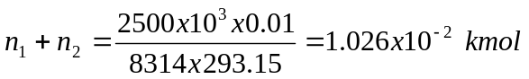
Therefore, n₂ = 1.026 * 10⁻² -6.15 *10⁻³ = 4.11 *10⁻³ kmol

3. Moles of propane, n₃ = (mass of propane)/(molar mass of propane) =
(0.010 kg)/(44.097 kg/kmol) = 2.27 * 10⁻⁴ kmol
Total number of moles, n = n₁+n₂+n₃ = 1.026 * 10⁻² + 2.27 * 10⁻⁴ = 0.01049 kmol

P = (nRT)/V

